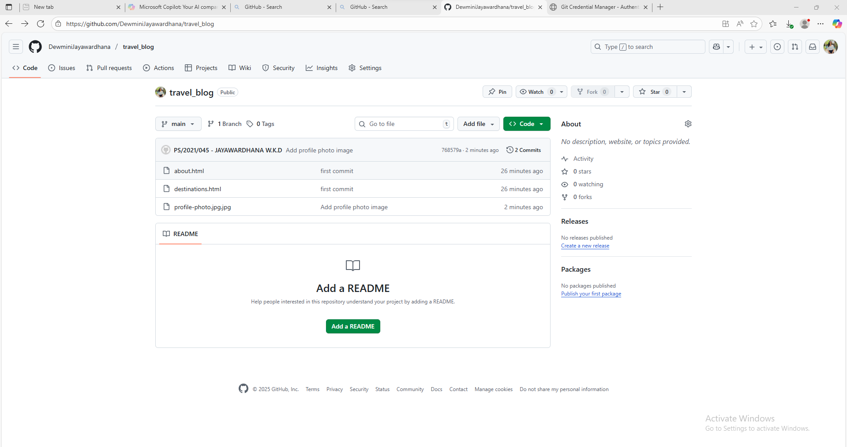

[DewminiJayawardhana (Dewmini Jayawardhana)](https://github.com/DewminiJayawardhana)

